**Experiment 01**

**Aim:** Getting introduced to data analytics libraries in Python.

**Theory:** In this we will be focusing on only three libraries of Python for this experiment. First NumPy, second Pandas, and third statistics.

Let us first study about this two libraries. What are these, uses, and many more …… ?

1. NumPy

NumPy stands for Numerical Python. The most powerful feature of NumPy is n-dimensional array. This library also contains basic linear algebra functions, Fourier transforms, advanced random number capabilities and tools for integration with other low level languages like Fortran, C and C++.

1. Pandas

Pandas is an open source Python package that is most widely used for data science/data analysis and machine learning tasks. It is built on top of another package named Numpy, which provides support for multi-dimensional arrays.

1. Statistics

Python's statistics is a built-in Python library for descriptive statistics. You can use it if your datasets are not too large or if you can't rely on importing other libraries. NumPy is a third-party library for numerical computing, optimized for working with single- and multi-dimensional arrays.

**Code & Output:**

1. NumPy

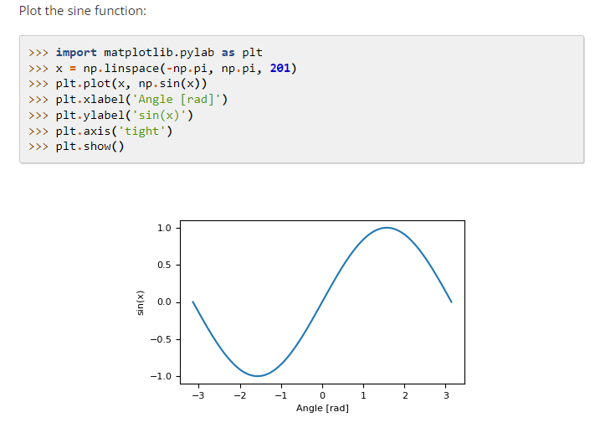

Figure : Sine waves using NumPy

1. Pandas



Figure : Importing Pandas Library to use

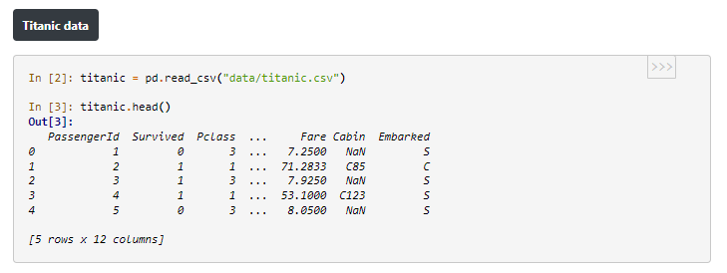

Figure : Titanic data set

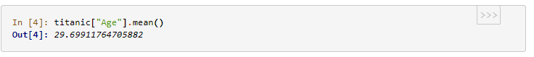

Figure : Average age

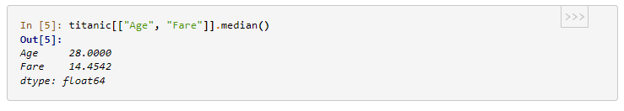

Figure : Middle value of column 'Age' & 'Fare'

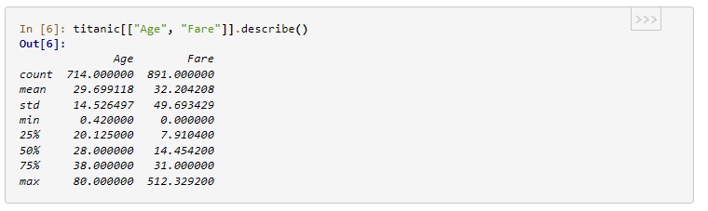

Figure : Aggregate (Descriptive) Statistics

1. Statistics

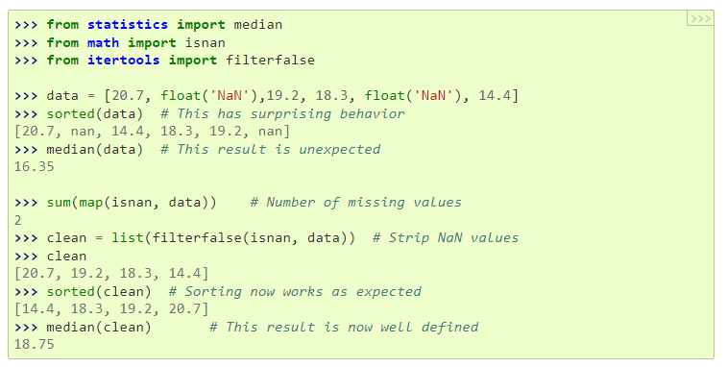

Figure : Descriptive statistcs

**Conclusion:** Thus we have performed the experiment. We learned using python libraries for descriptive statistics.